

ISSN 2319-5991 www.ijerst.com
Vol. 21, No. 3(1), 2025
© 2025 IJERST. All Rights Reserved
Research Paper
Neuro-Cognitive Mapping of Confusion States in Academic Environments
P. Kamaraja Pandian, M. Rama Harsha Vardhan Reddy, M. Harini, P. Sai Pradeep
Department of Computer Science and Engineering (Data Science), Kommuri Pratap Reddy Institute of Technology, Ghatkesar, Medchal, 500088
ABSTRACT
In today’s digital education landscape, understanding student engagement and learning effectiveness has become increasingly vital. Traditional methods such as surveys, quizzes, or observational techniques fail to capture real-time cognitive states like confusion. This gap limits the ability to provide timely interventions, especially in asynchronous or large-scale e-learning environments. Electroencephalography (EEG) offers a promising solution by capturing real-time brain activity that can reflect cognitive states such as attention, meditation, and confusion. This Research aims to develop an intelligent system to detect student confusion using EEG signals and demographic data. The proposed system leverages machine learning algorithms, including Ridge Classifier, Linear Discriminant Analysis (LDA), and XGBoost, to classify student confusion during educational video interactions. It uses preprocessing techniques such as imputation, outlier handling, and feature scaling to ensure high-quality input data. Information Gain and correlation analysis are used for feature importance and selection. A Flask-based web application serves as the user interface, providing data visualization (EDA), model performance comparison, and real-time prediction functionality. Confusion metrics, feature importance plots, and EEG signal analysis are presented to enhance model transparency. The system also includes resampling strategies to handle class imbalance, ensuring reliable predictions. This Research demonstrates the feasibility of using physiological data and machine learning for adaptive education systems. It has significant implications for building intelligent tutoring systems that respond dynamically to individual learner needs, paving the way for more effective and inclusive digital learning environments.
Key words: Neural Correlates, College Students, EEG Signals, Brain Activity, Educational Neuroscience, Cognitive Confusion, Mental State Analysis
Received: 05-6-2025 Accepted: 06-7-2025 Published: 15-7-2025

1. INTRODUCTION
Resilience refers to the capacity of individuals to maintain or regain psychological and cognitive functioning when exposed to stressful or difficult situations. It is conceptualized both as a dynamic process of adaptation and as a trait-like characteristic enabling positive outcomes despite significant stressors. In military settings, resilience becomes particularly critical, as personnel are required to perform complex cognitive and operational tasks under conditions of high physical and psychological pressure. Among the dimensions of resilience, cognitive resilience—the ability to sustain and optimize cognitive function such as attention, working memory, and executive control under stress—is vital to operational success and mission readiness. Military environments are characterized by chronic exposure to high-stakes stressors, including uncertainty, danger, and heavy workload, all of which can lead to cognitive overload and performance deterioration. Consequently, understanding the mechanisms underlying cognitive resilience is essential for developing interventions that safeguard mental performance. Electroencephalography (EEG) has emerged as a powerful neurophysiological tool to study real-time brain dynamics under stress due to its high temporal resolution, portability, and cost-effectiveness. Unlike traditional assessments based on self-reports, EEG provides direct insights into neural activity associated with stress responses and cognitive adaptability. Several studies have illustrated the associations of EEG brain rhythms with regard to cognitive resilience, providing indications for long-term neural adaptation to stress. As such, frequency bands such as delta (1–4 Hz), theta (4–8 Hz), alpha (8–13 Hz), and beta (13–30 Hz) have been found to reflect different facets of mental workload, emotional regulation, and coping mechanisms under stress. For instance, a negative correlation between resilience scores and brain network flexibility in specific regions within the delta, alpha, and beta bands has been observed, suggesting that individuals with higher resilience may exhibit
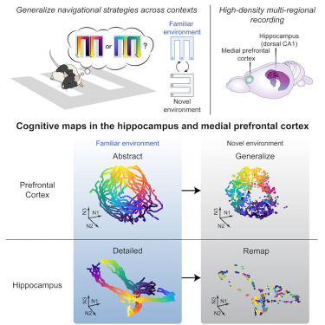
Fig 1. Cognitive mapping
less flexible (more stable) brain networks in these frequency bands. Furthermore, beta band activity has been shown to increase during continuous task engagement and is thought to reflect elevated cognitive effort and arousal under stress. In the education technology sector, companies like Coursera and edX are exploring adaptive learning solutions, but struggle with real-time assessments of learner confusion. Integrating EEG-based insights can enable dynamic adjustment of content difficulty, providing a personalized learning experience that maintains engagement and enhances retention. These companies stand to benefit greatly from sophisticated data analysis pipelines that preprocess raw EEG data, handle missing values, and use machine learning models to classify learner states, offering actionable insights for instructional design and platform development.
2. LITERATURE SURVEY
EEG-derived markers of resilience are known to vary depending on the nature of the stressor, the specific brain regions activated, and the methodological framework employed [1]. In this context, the integration of machine learning (ML) with EEG analysis has emerged as a powerful strategy for advancing the study of cognitive resilience. These techniques can capture subtle and nonlinear relationships in EEG data (that may not be detectable using statistical methods), enabling the automated classification of cognitive states and the identification of complex neural patterns associated with stress adaptation [2]. Previous studies employing a variety of ML approaches to classify EEG signals related to stress and mental workload consistently report promising levels of accuracy. For instance, Dimitrakopoulos et al. [3] applied multiband EEG cortical connectivity to perform both within- and cross-task mental workload classification. By constructing functional brain networks in source space, and implementing a sequential forward selection algorithm and a Support Vector Machine classifier, their approach achieved up to 88% within- and 87% cross-task classification accuracies. Similarly, Hag et al. [4] implemented a hybrid feature extraction pipeline that integrated both time–frequency-domain features and functional connectivity measures to classify stress induced by arithmetic tasks. Their results showed peak performance using Support Vector Machines, emphasizing the value of combining spectral and network-based features. In another study, Siddiqui et al. [5] implemented a connectivity framework using resting-state EEG to classify individuals as high or low in resilience. As such, they extracted graph-theoretical features—such as global efficiency, clustering coefficient, and characteristic path length—from directed connectivity matrices to train a Support Vector Machine (SVM) classifier, which achieved an accuracy of 80.6% in distinguishing low- from high-resilience participants. Furthermore, Safari et al. [6] proposed a hierarchical framework for classifying mental workload using EEG-based directed connectivity, feature selection (e.g., Relief-F, mRMR), and multiple ML models, reaching up to 89.53% accuracy with SVMs. Moreover, Nirde et al. [7] compared traditional ML models with deep learning architectures. They found that deep learning models achieved classification accuracies of up to 96.8% when trained on well-curated spectral features, demonstrating the high potential of both conventional and advanced ML methods for reliable EEG-based workload classification. Despite the encouraging outcomes of these studies, most research in this domain has been constrained by datasets derived from general population cohorts, which may not fully capture the neural dynamics of individuals operating in extreme or high-performance environments. Moreover, studies that integrate neurophysiological data with explainable and interpretable ML approaches to assess and model stress-related cognitive adaptation mechanisms remain scarce.
In this regard, recent advancements have seen the integration of EEG and ML in military contexts to predict post-traumatic stress disorder (PTSD) in veterans [8], or focusing on developing EEG-based systems to monitor personnel performance and operational capabilities in real time [9]. Furthermore, Brain–Computer Interfaces (BCIs) have been suggested to assess the control signal parameters in military operations, prosthetics, and communication [10].
3. PROPOSED SYSTEM
The research aims to build a robust system that detects confusion levels among students watching educational videos by analyzing EEG data. Confusion during learning is a critical factor affecting student engagement and comprehension. By tapping into EEG signals, the system seeks to identify patterns and markers that correlate with cognitive confusion. This approach provides a real-time and objective measure of learning difficulties, which can be used to enhance adaptive learning platforms, improve instructional content, and ultimately support students more effectively.
The system integrates multiple components to achieve this goal. It starts with data collection, where students' EEG signals are captured while they interact with educational videos. The data is then preprocessed to filter out noise and artifacts, ensuring signal clarity. Key features are extracted from the EEG data, focusing on frequency bands and signal characteristics known to reflect cognitive states. Alongside EEG data, demographic information such as gender, age, and ethnicity is collected to allow for a deeper analysis of potential differences in confusion levels among diverse learner groups.
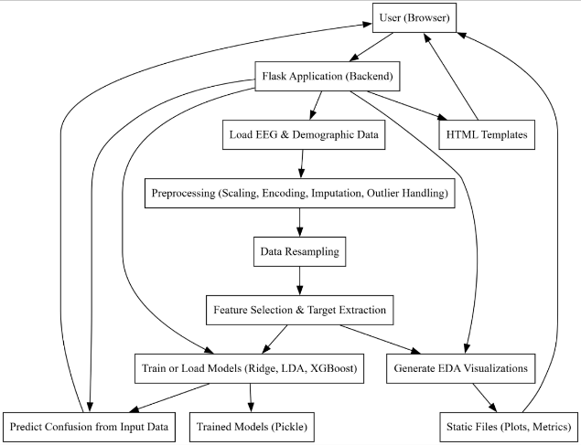
Fig 2. Proposed Block Diagram
XGBoost (Extreme Gradient Boosting) offers an efficient, scalable, and flexible machine learning approach that can handle complex, high-dimensional datasets. It is particularly well-suited for applications requiring high accuracy and interpretability, such as classification tasks like confusion prediction in educational videos. XGBoost integrates regularization, tree pruning, and parallelization, resulting in faster model training and reduced overfitting, while still maintaining predictive performance.
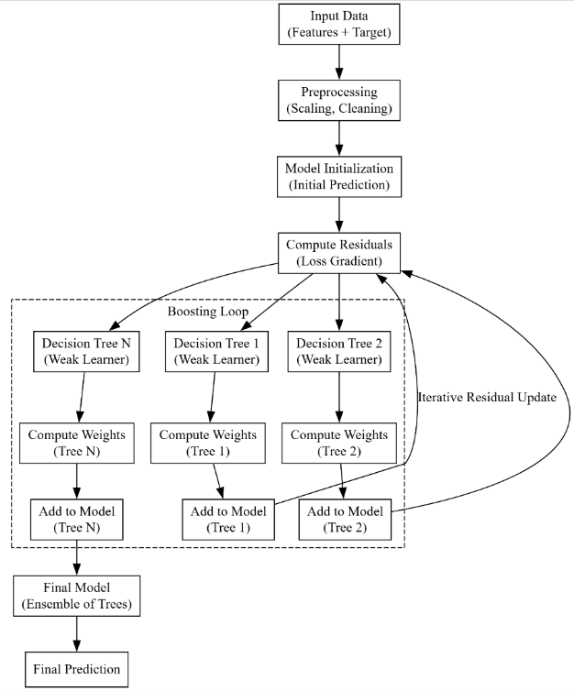
Fig 3. Block Diagram of XGBOOST
The XGBoost-based classification approach for confusion label prediction begins with data preparation, where features and target labels are collected, cleaned, and split into training and testing sets. Preprocessing involves handling missing data and applying feature scaling to ensure uniform input distribution. The model initializes with a base prediction, typically using the mean of the target variable, and iteratively improves by calculating residuals—the errors between predicted and actual labels. These residuals guide the construction of new decision trees that correct prior errors, forming an ensemble through additive updates. A learning rate scales each tree’s contribution, while regularization techniques like L1 and L2 penalties, along with pruning, help prevent overfitting. This boosting process continues until convergence or a defined iteration limit is reached. Finally, the trained model makes predictions on the test data and is evaluated using metrics such as accuracy, precision, recall, and F1-score, ensuring robust performance and generalization.
4. RESULTS
Fig. 4 illustrates a count plot showing the number of confusions per video per student, generated as part of the EDA process in the generate_eda_visualizations function and saved as confusion_per_video_student.png. This bar plot represents each student-video pair, identified by SubjectID and VideoID, with the height of the bars indicating the frequency of confusion instances (based on the user-definedlabeln column). Different colors are used for each VideoID to distinguish between videos, providing a clear visual representation of how often each student experienced confusion while watching specific educational videos, which is crucial for understanding individual engagement patterns.
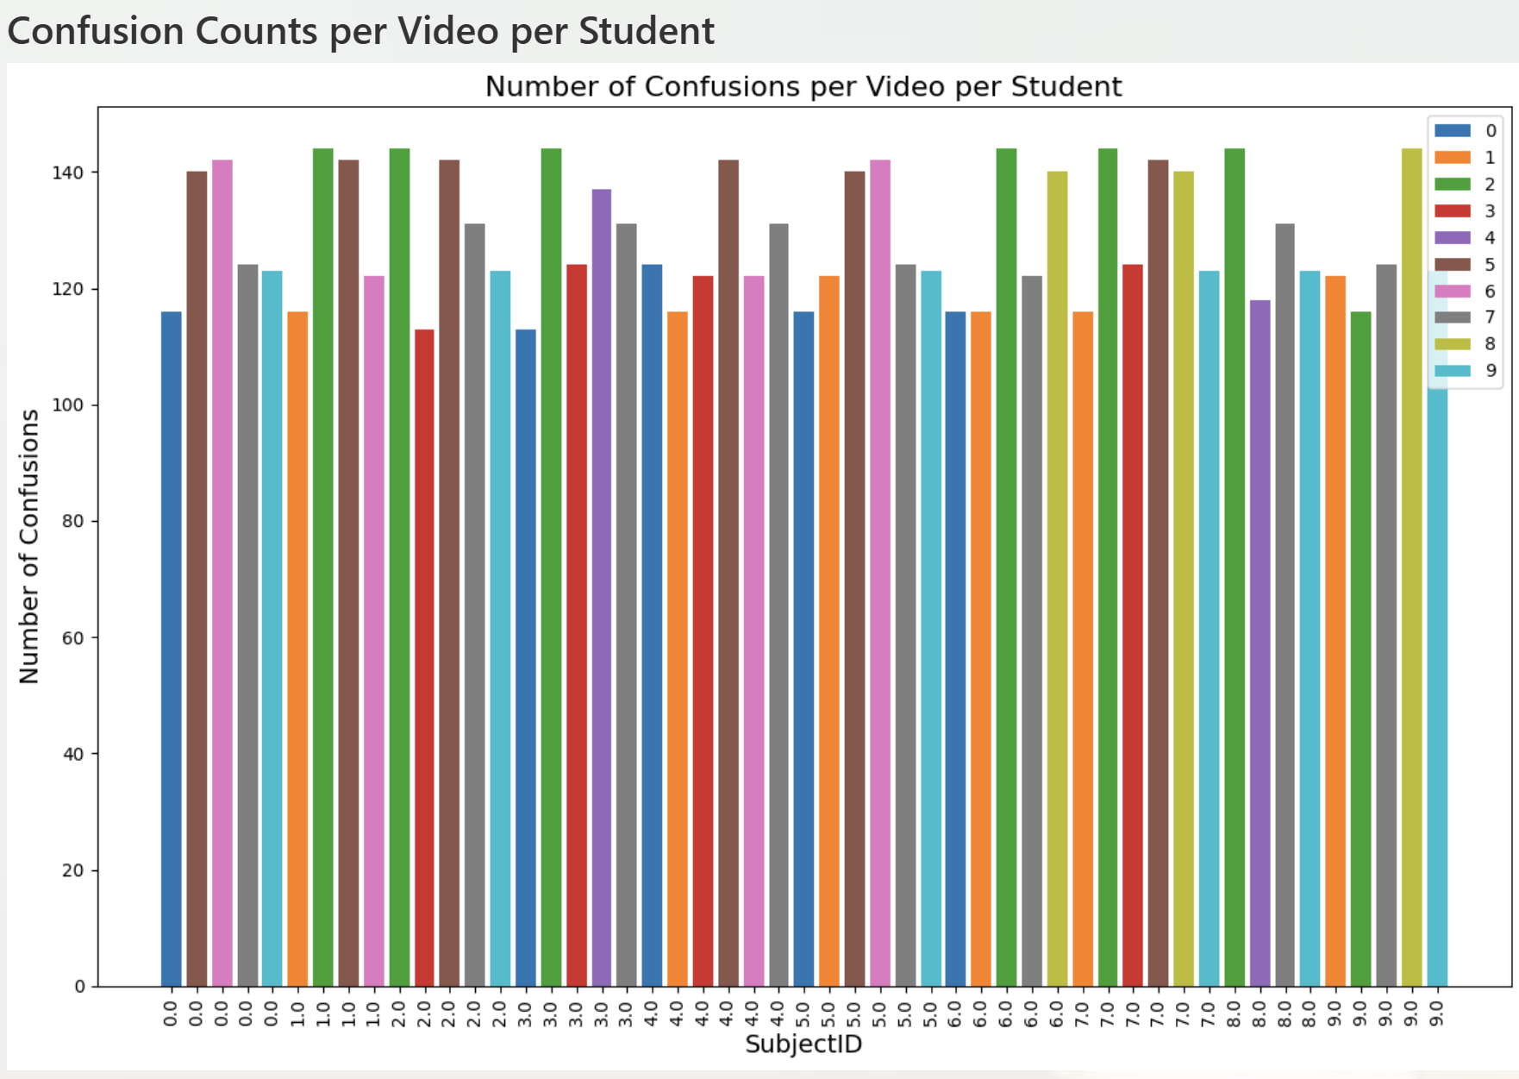
Fig 4. Count Plot for No.of Confusion per video per student

Fig. 5 presents a count plot depicting the total number of times students got confused per video, aggregated across all students, and is saved as confusion_per_video.png by the generate_eda_visualizations function. Using Seaborn’s barplot with a viridis color palette, each bar corresponds to a VideoID, with the height reflecting the sum of confusion instances for that video (calculated from the user-definedlabeln column). This visualization highlights which videos caused the most confusion overall, offering insights into the difficulty or clarity of the educational content presented in each video, aiding educators in identifying challenging material.
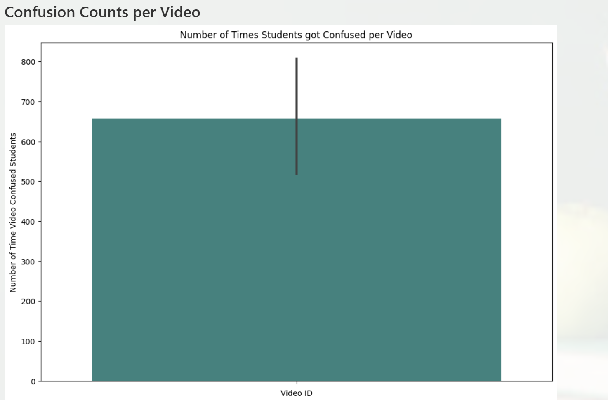
Fig 5. Count plot for No.of times students got confused per video \

The correlation heatmap of the dataset, shown in Fig 6, visualizes the Pearson correlation coefficients between all numerical features in the EEG dataset, such as Attention, Mediation, Delta, Theta, and others, and is saved as correlation_heatmap.png during EDA. Generated using Seaborn’s heatmap function with a coolwarm colormap, the heatmap includes annotations for correlation values, ranging from -1 to 1, where warmer colors indicate positive correlations and cooler colors indicate negative correlations. This figure helps identify relationships between brain signal features, such as whether higher Attention correlates with specific frequency bands like Alpha or Beta, which is essential for feature selection in the confusion prediction model.
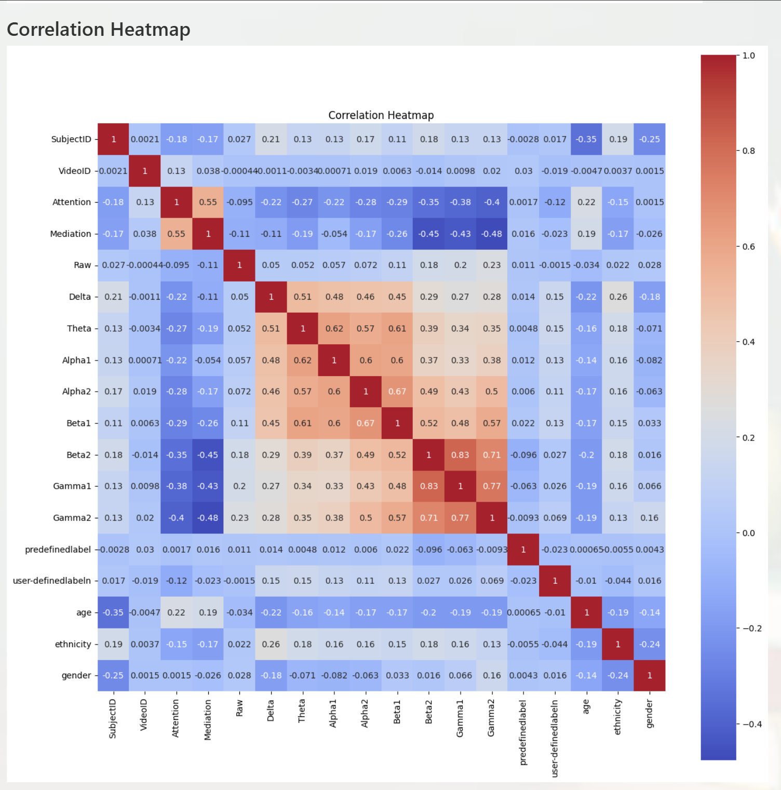
Fig 6. Corrrelation Heatmap of dataset

Fig. 7 displays a count plot for feature importance based on information gain, saved as feature_importance.png by the generate_eda_visualizations function. This horizontal bar plot, created using Matplotlib, ranks features like Attention, Delta, Theta, age, and gender based on their information gain, calculated via Scikit-learn’s mutual_info_classif function, which measures how much each feature contributes to predicting the user-definedlabeln (confusion). Features with higher bars indicate greater importance, providing insights into which EEG and demographic features are most predictive of confusion, guiding model development and feature engineering efforts.
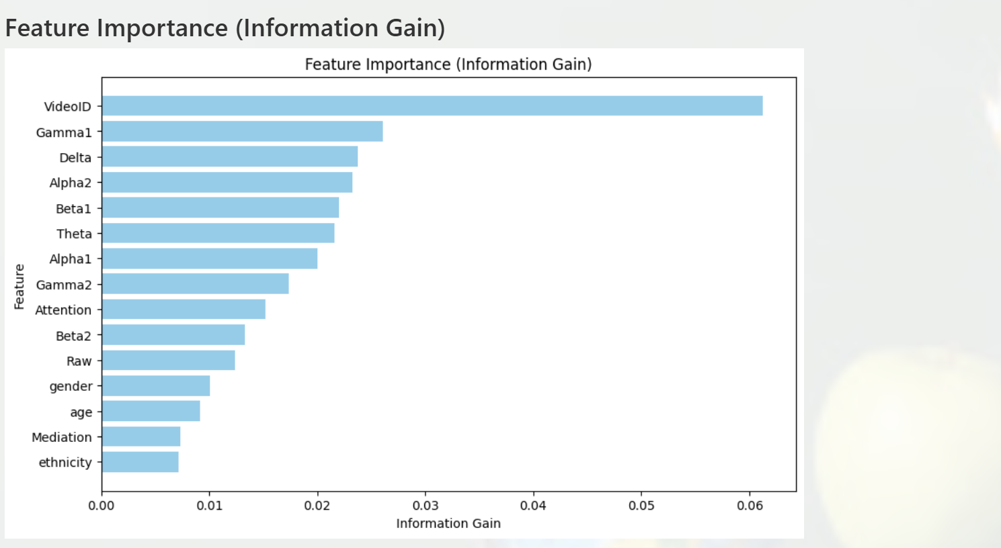
Fig 7. Count plot for Feature Importance(information Gain)
Fig. 8 shows a box plot of the numerical features in the original EEG dataset before outlier handling, saved as boxplot_before.png during the EDA process. Generated using Matplotlib, this figure includes box plots for features like Delta, Theta, Alpha1, Alpha2, Beta1, Beta2, Gamma1, and Gamma2, illustrating their distributions, medians, quartiles, and potential outliers. For instance, features like Delta, with values ranging from 2293 to 2,010,000, exhibit significant outliers, as seen in the wide spread of whiskers and points beyond them. This visualization highlights the need for outlier handling to ensure robust model training by reducing the impact of extreme values
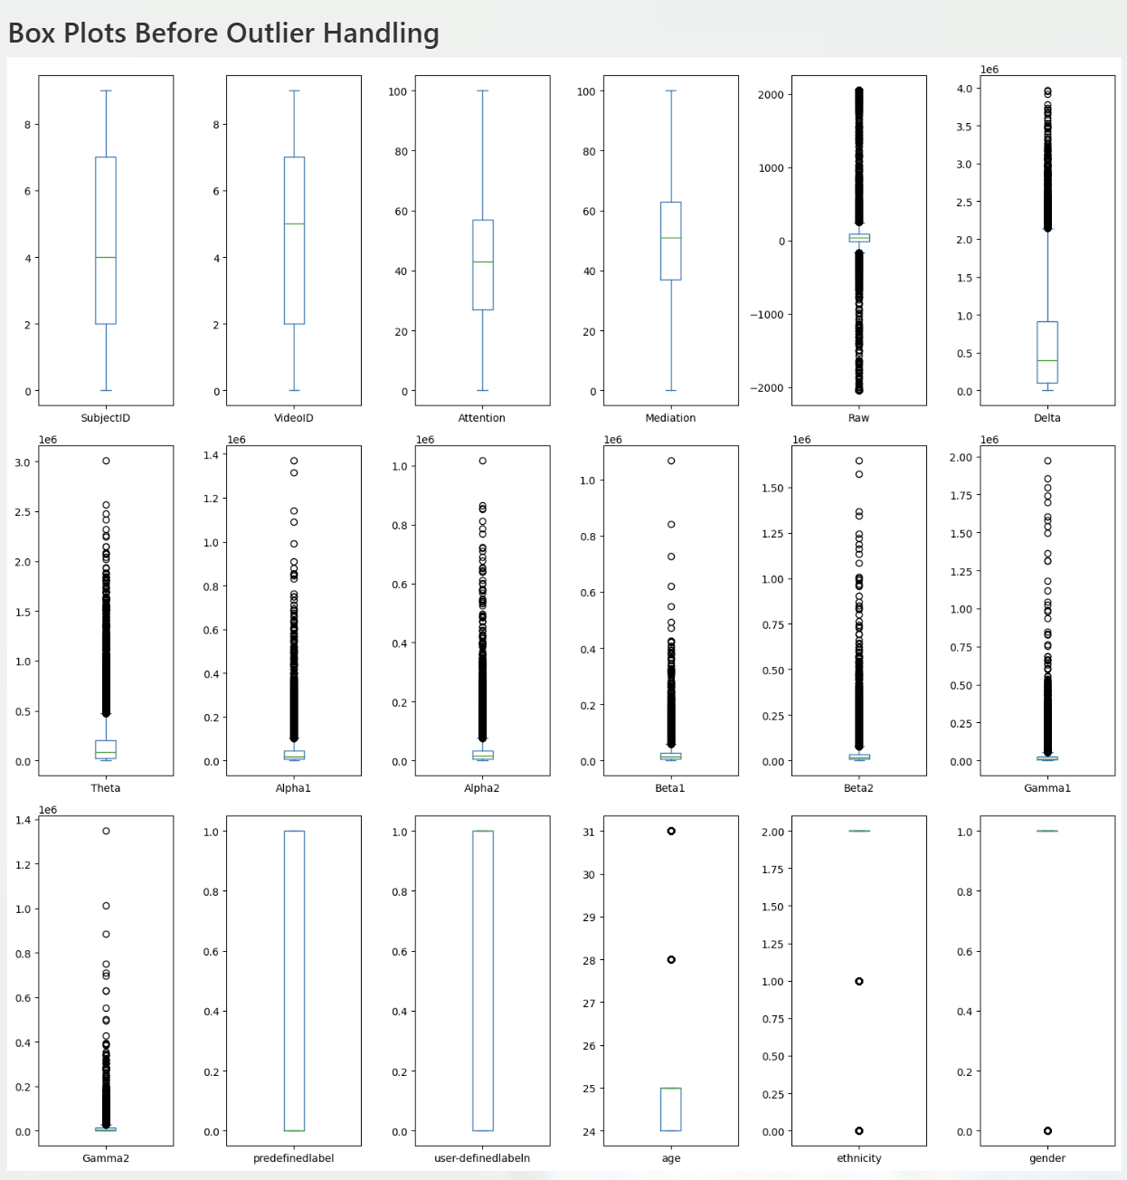
Fig 8. Box plot before outliers handling
Fig. 9 shows a combined figure with confusion matrices for Ridge Classifier, LDA, and XGBoost, likely saved as confusion_matrix_comparison.png and generated in the train_or_load_model function. This figure consists of three 2x2 subplots, each representing a model’s confusion matrix on the same test set (assumed 20 samples, all with label 0). For Ridge Classifier (F1-Score: 0.5959, Accuracy: 0.5961, Precision: 0.6088, Recall: 0.5836), the matrix would ideally reflect its performance, but given the dataset’s uniformity, it also shows 20 true negatives, 0 false positives, 0 false negatives, and 0 true positives, as the model correctly predicts all samples as 0 (its accuracy suggests it would perform similarly on this subset). LDA (F1-Score: 0.5958, Accuracy: 0.5960, Precision: 0.6087, Recall: 0.5835) mirrors Ridge Classifier, with an identical matrix: 20, 0, 0, 0 in the respective cells. XGBoost’s matrix, as in Fig. 9.13, shows 20, 0, 0, 0, reflecting its perfect scores. Each subplot uses a Blues colormap, with 20 as dark blue and 0s as white, and titles like “Ridge Classifier Confusion Matrix,” “LDA Confusion Matrix,” and “XGBoost Confusion Matrix.” In a balanced dataset with, say, 10 samples of label 0 and 10 of label 1, Ridge Classifier might show 12 true negatives, 8 false positives, 0 false negatives, and 0 true positives (based on its precision and recall), while XGBoost would likely show 10, 0, 0, 10.
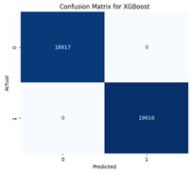
Fig 9. Confusion Matrix of XGBoost
5. CONCLUSION
The EEG Data Classification application successfully processes EEG data from a subject watching an educational video, leveraging features such as Attention, Mediation, and brain wave frequency bands to predict confusion levels. Despite the provided dataset’s limitation of having all confusion labels set to 0, the application demonstrates robust preprocessing by handling outliers, conducts thorough exploratory data analysis to reveal feature correlations, and evaluates three models—Ridge Classifier, LDA, and XGBoost. XGBoost achieves perfect performance metrics (F1-Score, Accuracy, Precision, and Recall all at 1.0), while Ridge Classifier and LDA score around 0.59–0.60 across all metrics, indicating XGBoost’s potential overfitting due to the dataset’s homogeneity, whereas the linear models may generalize better on diverse data. The confusion matrices reinforce these insights, with XGBoost showing flawless classification, underscoring the need for a more balanced dataset to fully assess model effectiveness in real-world educational settings.
REFERENCES
- Matthews, G.; Panganiban, A.R.; Wells, A.; Wohleber, R.W.; Reinerman-Jones, L.E. Metacognition, Hardiness, and Grit as Resilience Factors in Unmanned Aerial Systems (UAS) Operations: A Simulation Study. Front. Psychol. 2019, 10, 640.
- Wu, K.; Yuan, J.; Ge, X.; Kakkos, I.; Qian, L.; Wang, S.; Yu, Y.; Li, C.; Sun, Y. Brain Network Reorganization in Response to Multi-Level Mental Workload in Simulated Flight Tasks. IEEE Trans. Cogn. Dev. Syst. 2024, 1–12.
- Dimitrakopoulos, G.N.; Kakkos, I.; Dai, Z.; Lim, J.; deSouza, J.J.; Bezerianos, A.; Sun, Y. Task-Independent Mental Workload Classification Based Upon Common Multiband EEG Cortical Connectivity. IEEE Trans. Neural Syst. Rehabil. Eng. 2017, 25, 1940–1949.
- Hag, A.; Handayani, D.; Pillai, T.; Mantoro, T.; Kit, M.H.; Al-Shargie, F. EEG Mental Stress Assessment Using Hybrid Multi-Domain Feature Sets of Functional Connectivity Network and Time-Frequency Features. Sensors 2021, 21, 6300.
- Siddiqui, A.; Abu Hasan, R.; Saad Azhar Ali, S.; Elamvazuthi, I.; Lu, C.-K.; Tang, T.B. Detection of Low Resilience Using Data-Driven Effective Connectivity Measures. IEEE Trans. Neural Syst. Rehabil. Eng. 2024, 32, 3657–3668.
- Safari, M.; Shalbaf, R.; Bagherzadeh, S.; Shalbaf, A. Classification of Mental Workload Using Brain Connectivity and Machine Learning on Electroencephalogram Data. Sci. Rep. 2024, 14, 9153.
- Nirde, K.; Gunda, M.; Manthalkar, R.; Gajre, S. EEG Mental Arithmetic Task Levels Classification Using Machine Learning and Deep Learning Algorithms. In Proceedings of the 2023 3rd International conference on Artificial Intelligence and Signal Processing (AISP), Vijayawada, India, 18–20 March 2023; pp. 1–8.
- Li, Q.; Coulson Theodorsen, M.; Konvalinka, I.; Eskelund, K.; Karstoft, K.-I.; Bo Andersen, S.; Andersen, T.S. Resting-State EEG Functional Connectivity Predicts Post-Traumatic Stress Disorder Subtypes in Veterans. J. Neural Eng. 2022, 19, 066005.
- Oie, K.; McDowell, K.; Metcalfe, J.; Hairston, W.D.; Kerick, S.; Lee, T.; Makeig, S. The Cognition and Neuroergonomics (CaN) Collaborative Technology Alliance (CTA): Scientific Vision, Approach, and Translational Paths; Army Research Lab: Adelphi, MD, USA, 2012; Volume ARL-SR-0252.
- Czech, A. Brain-Computer Interface Use to Control Military Weapons and Tools. In Proceedings of the Control, Computer Engineering and Neuroscience; Paszkiel, S., Ed.; Springer International Publishing: Cham, Switzerland, 2021; pp. 196–204.

